2014
08
Fall
ProofPass User Guide
by ColorMetrix Technologies LLC

Table of Contents

Download the ProofPass Client Using Setup Wizard ……………………3

Taking a Measurement with the ProofPass Client………………………. 4

Using ProofPass.com to View Measurement Data…………..…………. 7

How to Create a Data Set………………………………….……………………... 12

How to Copy a Data Set……………………………………………………………. 13

How to Create a Custom Reference…………………………………………. 14

How to Edit Tolerances for a Data Set ……………..……………………… 15

How to Search for Data Sets or Scans………………………………………. 16

Sharing Data Set Information Via Access Level Passwords…….…. 17

Sharing Single Specific Data Set Information Via Email ……………. 18

Troubleshooting, Tech Support, Feature Requests…………………….19

Download ProofPass Client

- Once you receive your ProofPass installation ID and password, log in to ProofPass.com (or dedicated server URL if you have one) in the upper right corner.

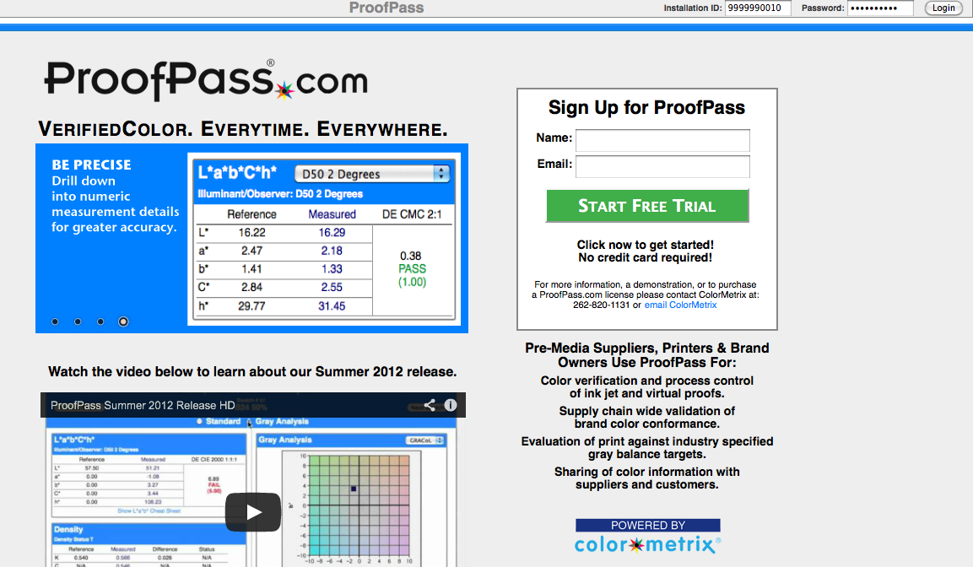

- Follow the Setup Wizard instructions to download the correct version for your operating system.

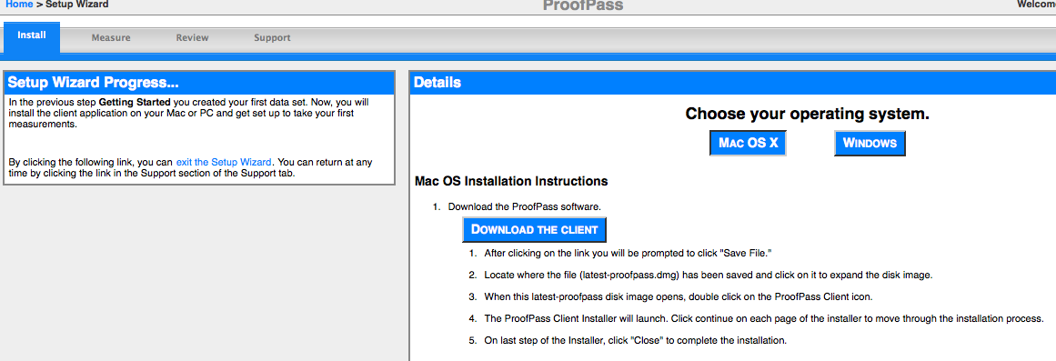
Taking a Measurement in ProofPass (client)

- Once the client is downloaded, launch it by selecting the starburst icon.
- From ProofPass -> Preferences, choose “Use ColorMetrix ProofPass Server” if you have a single seat or two on the ColorMetrix server or verify that the “Use Other ProofPass Server” button is highlighted and either the server name or the correct server IP address is entered.

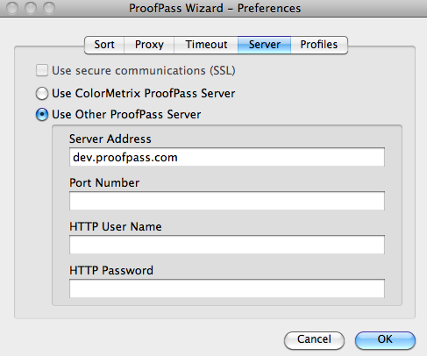

- From ProofPass -> Instrument, verify that the correct measuring instrument is selected. The ProofPass client may ask you to calibrate your instrument via a pop-up warning window before you measure. Once calibrated, you can measure as you normally would. NOTE: For process colors, select scan. For spot colors, select spot.

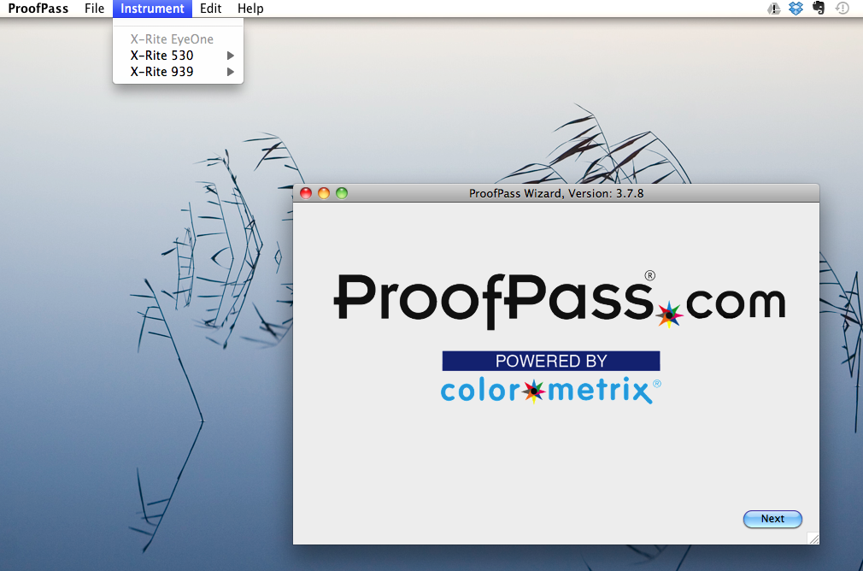

- Click Next and select your filter and data set preferences (these are set up on ProofPass.com) for the measurement. Then click Next.

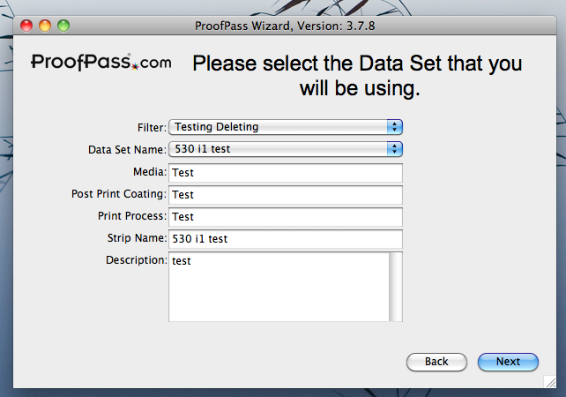
- Based on your filter and dataset choices, the correct control strip should appear in the window. Before you take your measurement, you can input metadata such as reference or job number in the designated spaces below the control strip window. This metadata will be saved as part of the name of the new data set once your measurement is complete. NOTE: After inputting the metadata, be sure to click off the editable boxes or your changes will not be saved.

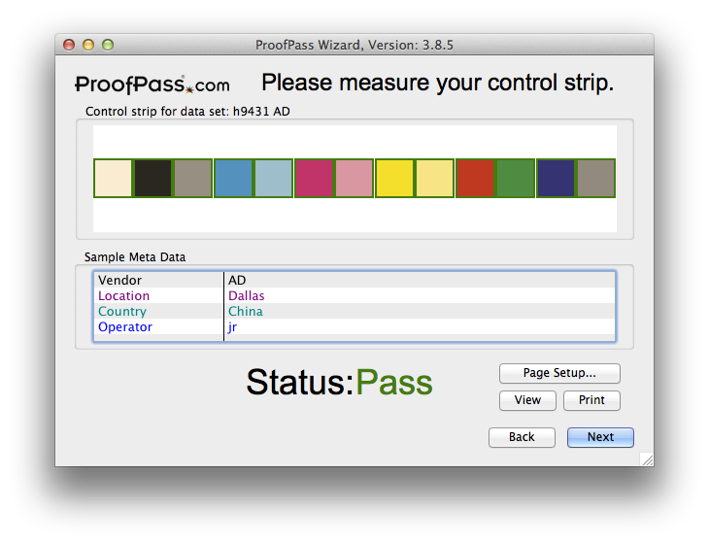

- After measurement, green (PASS) or red (FAIL) outlines should appear around each patch in the control strip in the window. Afterwards, a success window will pop up to tell you that your results have been posted to the server.

NOTE: When taking multiple measurements or to see new changes to data sets, filters, etc. on ProofPass.com, it is imperative that you hit the BACK button from the screen shown in Step 4. This updates the client. Then hit NEXT and you are ready to measure again and continue.
Using ProofPass.com (to view measurements)

- In the URL bar, type in ProofPass.com or your local server URL.
- Log in (at top right) using one your unique installation ID and password. (With admin password, you can change user and viewer passwords by going to Maintenance -> Account Settings. See Page 17 for more on passwords.)

- Once you are logged in, your measurement(s) will be listed under the Recent Activity tab. Your most recent measurement will be at the top. Note that the metadata you entered before measuring will be noted in each data set along with the time stamp of each. To view measurement information, click on the View button at right.

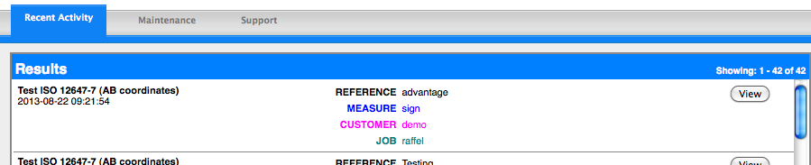

- From the Summary tab, you can view more detailed information about the scan. In the middle section labeled Sample Set, you can make the scan the reference for the dataset, create or custom reference or delete the scan altogether. Various printable detailed reports about the scan are available in the righthand column.

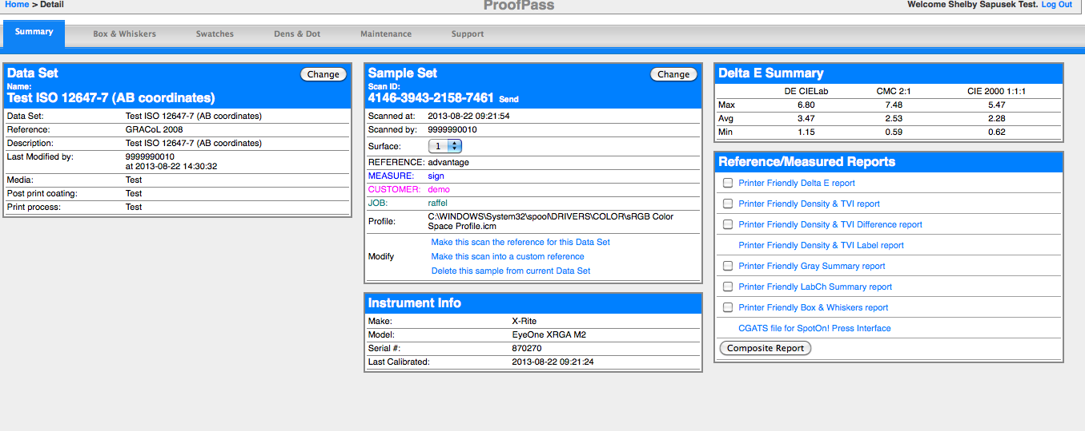

- The Box and Whiskers tab displays a box plot to show Delta E tendency over time within a data set. You can roll the mouse over any of the boxes or whiskers to show details of a particular scan. A printer-friendly version is available via a link at the bottom of the page.

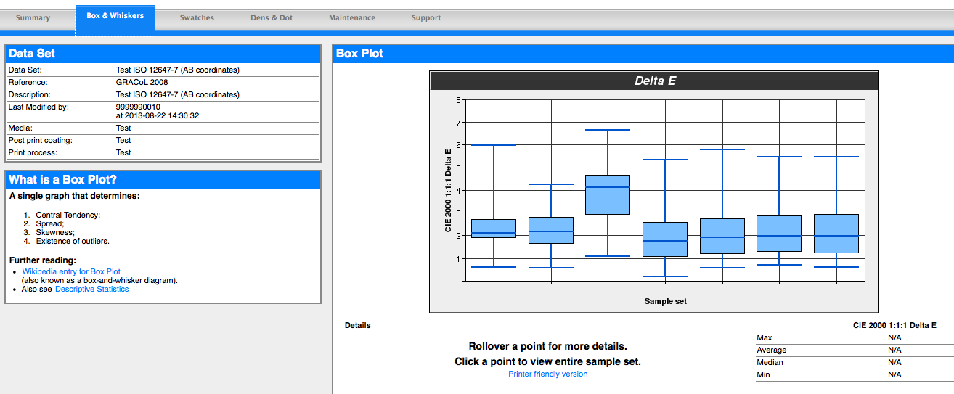

- There are many options in the Swatches tab. When the radio button at top right is set to Sample, you’ll see a spectral chart of the scan at right. On the left, you can see Delta E values of each swatch in the scan. By clicking on Delta E, you can sort by high and low.

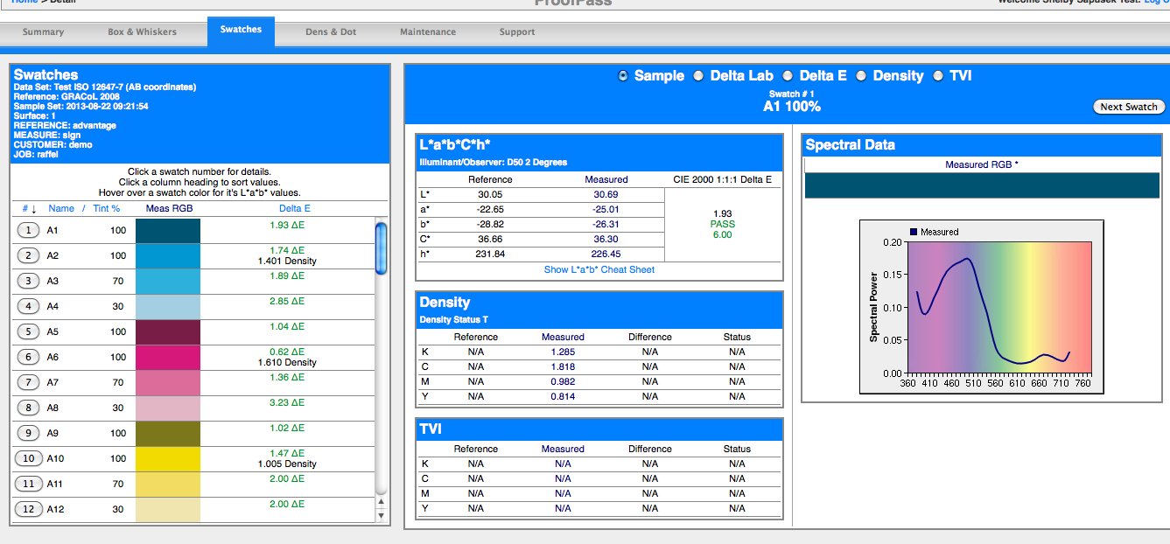

Switching the radio button to Delta Lab displays a chart similar to the one below. You can also view Delta E, density and TVI trends over time by clicking through the remaining radio buttons.

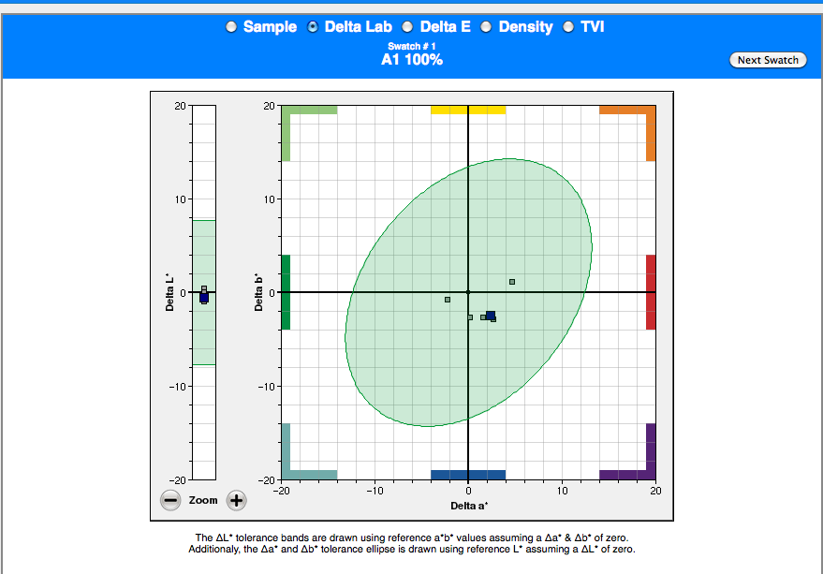

- The Dens and Dots tab allows you to select one or more swatches from your scan to see the trends in density, TVI or dot gain over time. The radio buttons to switch between each are in the same place as the previous Swatches screen. Printer-friendly options are available on each screen.

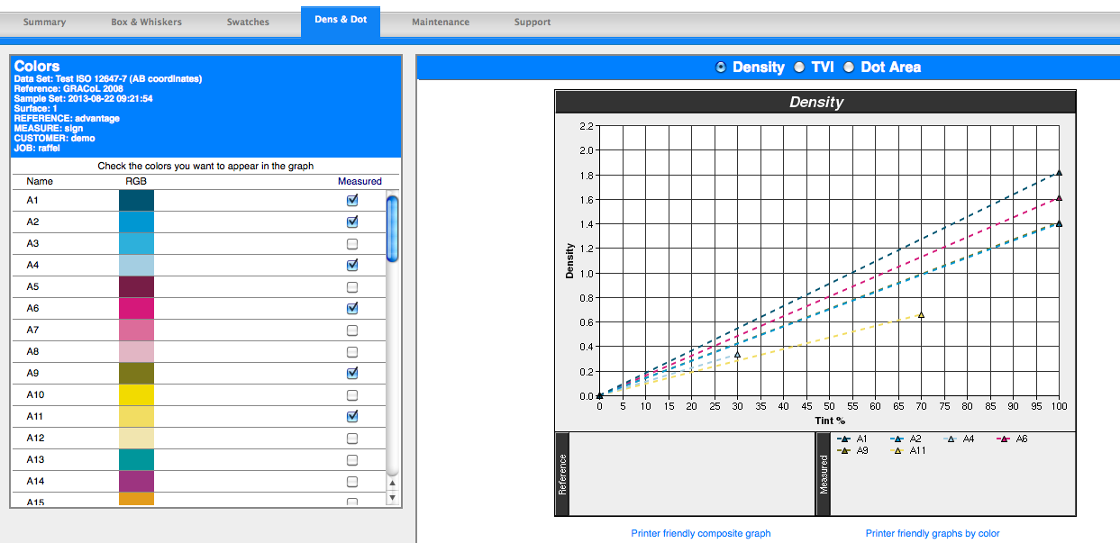

- The Maintenance tab allows you to create data sets, custom references, dataset filters and edit current tolerances within a data set. On the far right, you can modify how Delta E is calculated along with specifications for density, gray analysis and illuminant/observer. This is also the place where you can easily renew your subscription, add your company logo and set passwords.

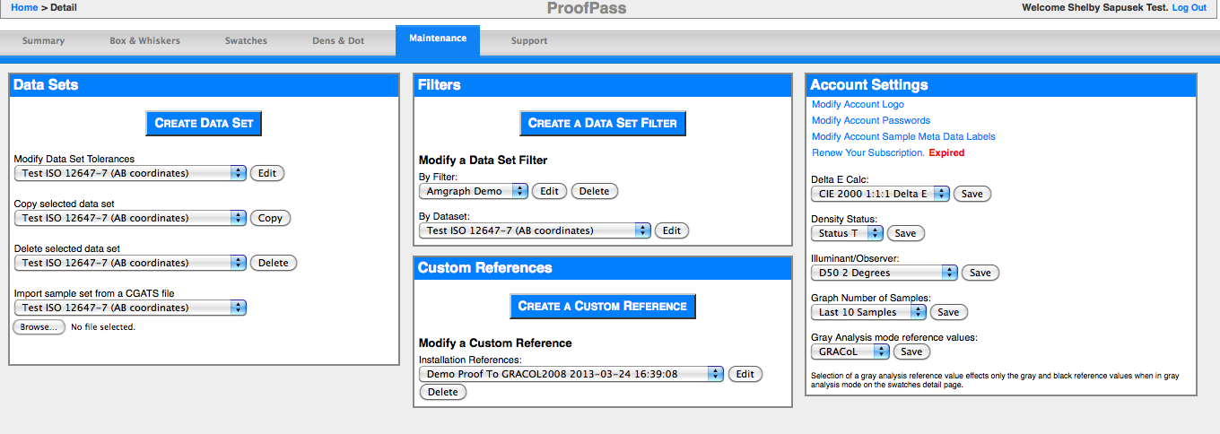
How to Create a Data Set
A data set is the starting point of the ProofPass system. Once a data set has been created by following the steps below, the client application can be utilized to measure control strips which will become sample sets within the data set. Navigate to the Maintenance tab and click on Create Data Set.
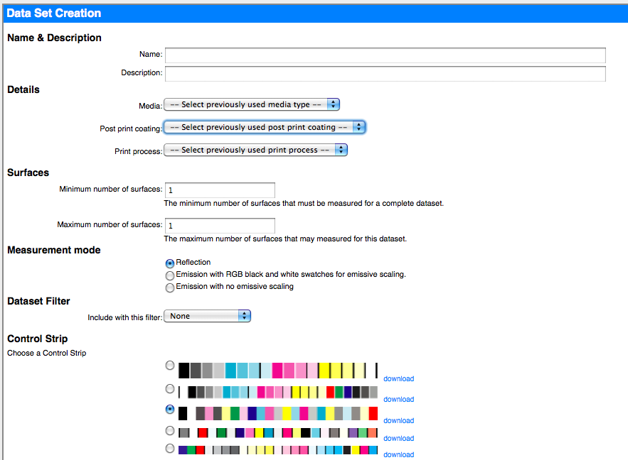
- Enter information in all fields in the Name & Description and Details Sections.
- To complete the Specify Other fields in the Details section, make sure you have selected Other from the drop down list. Then, type your new entry in the field.
- The Surfaces, Measurement Mode and Data Set Filter sections are optional and should be ignored initially unless you have specific needs to utilize these features.
- Select a control strip for use with this data set by clicking on the radio button to the left of the image.
- If necessary, download control strips in .eps and .ai format by clicking the download link to the right of the respective color bar.
- When satisfied with your choices, click the Create Data Set button at the bottom of this page. This will take you to the Set Swatch Tolerances page to complete your data set creation and configuration.

How to Copy a Data Set
From the Maintenance tab in the Data Sets block on the left side, select the data set from the second drop down menu and click Copy.
- Data Set Copy is a two step process. First, choose the reference values from the existing data set that you want to use for the copy. To use the existing data set's target values, select Use selected data set as the reference. To use one of the samples from the existing data set as the reference values for the copy, select a sample from the Source Sample Set drop-down list and make sure Use selected sample set as the reference is selected before clicking Continue to display page 2 of the copy process.
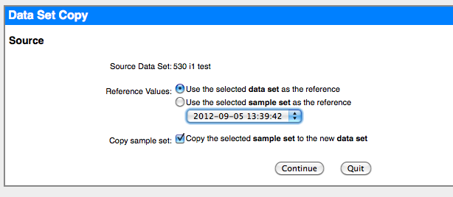
- On this page, you choose one or more destination installation IDs. If you click on one and hold down the shift key and click another, the first, last, and every one in between is selected. If you hold down the control key, you can click one at a time to add or remove that installation ID from the destination list. Enter the necessary password and edit any of the other fields as necessary. Finally, click Copy Data Set to complete the process.
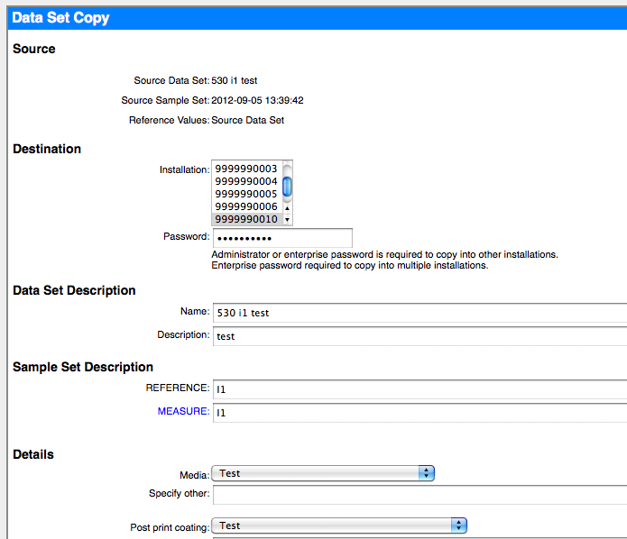

How to Create a Custom Reference
You can create or modify custom references by going to the Maintenance tab and working within the middle Custom References block. Click on Create a Custom Reference.
Type in a unique name for your custom reference. Choose a color bar to which you’d like to associate the custom reference. Then click Submit at the bottom of the page.
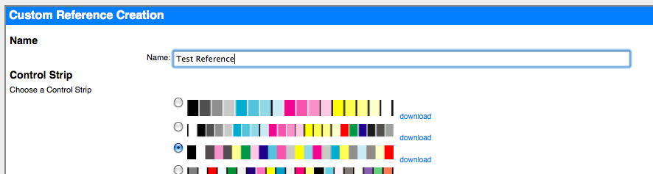
On the next page, you will be asked to manually input CMYK percentages (note that it is in KCMY order) and L*a*b* values. Obviously, it is important that these values are correct so we recommend checking over your work before clicking Update Custom Reference at the bottom of the page. However, if you do make a mistake, you can always edit the reference back on the Maintenance tab in the Custom References block. Choose the reference name from the drop down menu and then click edit.
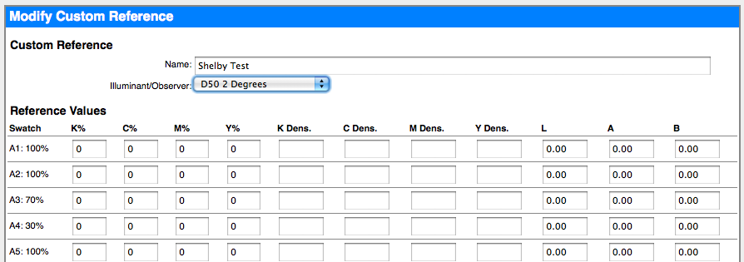

How to Edit Tolerances
Tolerances are the key to evaluating differences between reference measurements and new samples. While not essential to ProofPass operation, tolerances do enable instant Pass/Fail evaluation of samples measured with the ProofPass client software application. Navigate to the Maintenance tab, and click the Edit button on the left next to Modify Data Set Tolerances in the Data Sets block.
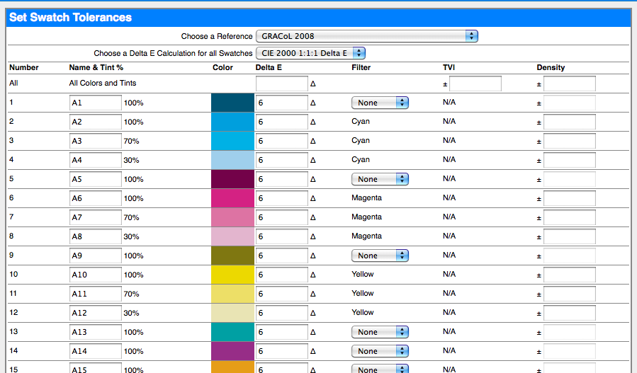
The following steps tell you how to configure your tolerances for a data set.
- Begin by selecting the appropriate delta E calculation method from the Choose a Delta E Calculation for all Swatches drop-down list.
- Next, the Name of each swatch can be changed to more accurately represent the colors you are measuring. If there are multiple occurrences of a color changing any of them will change all occurrences of that color. This is by design and can't be overridden.
- Tolerances for Delta E, TVI, and Density can be set for all swatches simultaneously by entering values in the All/All Color and Tints row.
- Alternatively, tolerances can be entered or adjusted for each swatch number. Also, tolerance values do not need to be entered into each and every field. Pass/Fail will be calculated based only upon those values that are entered.
- Changing the Filter associated with a swatch will determine which densitometric filter is used to apply the tolerance value entered.
- Finally, click the Submit button to confirm your changes or the reset button to exit without making changes.

How to Search for Data Sets or Scans
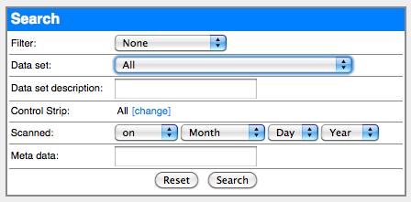
As you use ProofPass more, you will likely have many data sets in the system. While it is easy to find recent scans because they are always at the top in your Recent Activity, it may become necessary to find older scans. ProofPass allows you to search for particulars of a scan to make finding what you need easier. Navigate to the Recent Activity tab and use the menu on the right to search for a data set.
You can search by filter, a particular data set, description or meta data, a control strip, or creation date.

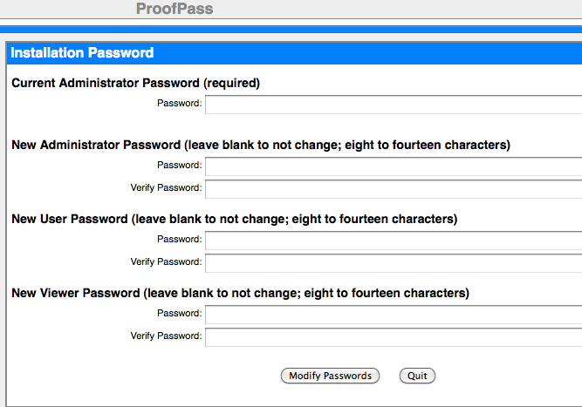

Sharing Data Set Information Via Access Level Passwords
As mentioned on Page 5, you can share data set information by providing access level appropriate passwords to team members, ink vendors, printers, etc. There are three levels of access:
- Administrator: Full control of data. Can create, delete, etc.
- User: Can scan (measure) into system to create data but cannot change or delete any.
- Viewer: Cannot add, change or delete data. Read only.
Passwords for these levels can be added/changed under Maintenance -> Account Settings. You must have admin privileges to make these changes.
This is a good way to share information between people who use the ProofPass system on a regular basis.
Sharing Specific Data Set Information Via Email
You can provide a link to a specific data set (instead of access to the entire system) to someone via email. This option is helpful when you’d like to share an older scan with someone so they don’t have to search for it in the system.
View a data set and remain on the Summary tab. In the middle Sample Set block, click on the Send button next to the Scan ID number.

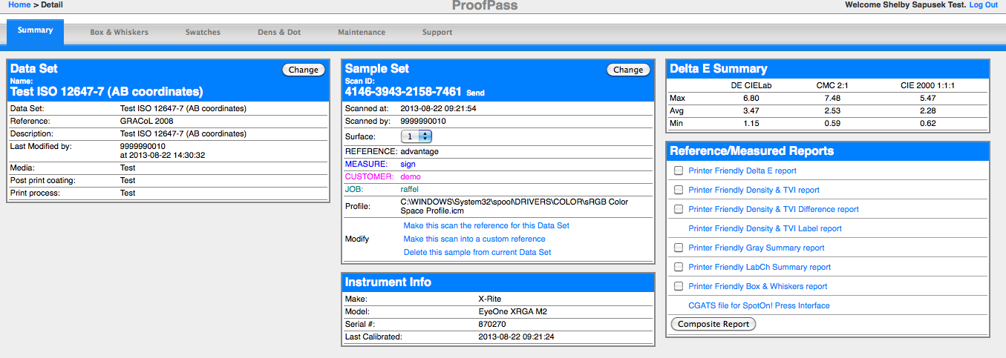
An email box will open with a unique link to that specific data set. Your user information will already be filled in. You can add a personal message to the email if you wish. Otherwise, simply fill in the recipient’s email address and click send.
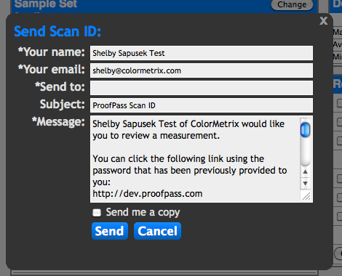
Troubleshooting, Support and Feature Requests
While this guide is intended to aid you in your day-to-day use of ProofPass, there are other features available within the system. By navigating to the Support tab, you can view some frequently asked questions about ProofPass and find our tech support and new feature request forms.
To report any problems with your ProofPass account or to discuss new development features or requests, please email ColorMetrix Project Manager Shelby Sapusek at Shelby@colormetrix.com or call her at
414-510-6590.

