2014
08
Fall
VerifiedColor User Guide
by ColorMetrix Technologies LLC

Table of Contents

Log in to VerifiedColor and set up ………………………….……………… 3

Create / associate printer locations & ink supplier….……………… 4

Create print customer ………………………………………..….……………… 5

File Import / Export ….………………………………………..….……………… 6

Create a Match Request ….…………………………….…..….……………… 8

Searching the Database ….…………………….……..…..….……………… 12

Recent Activity ….…………………….……..…..….…………………………… 13

Edit Records ….….…………………….……..…..….…………………………… 15

Troubleshooting & Feature Requests ..….…………..………………… 16

Log in to VerifiedColor and set up

- Once you receive your VerifiedColor username and password via email, navigate to the correct URL in your browser. (Typically, it is [your company].verifiedcolor.com.) Input your user name (which is usually your email address) and password. This password will at first be automatically randomized as numbers and letters. You can change it after you log in the first time. If at any time you forget your password, enter your email address under the Access Portal and click on the “Email New Password” button on the right.

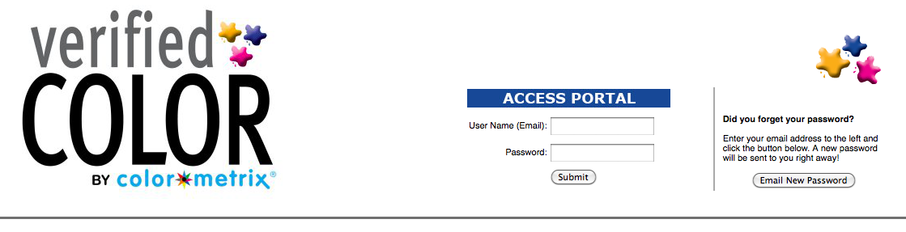

- The next screen you see after logging in is the home screen. When you log in for the first time, click on “My Account” on the righthand side of the screen under your name. Notice the “Your current instrument” is in red underneath your name. If you were not assigned an instrument in the setup process, the “My Account” screen is where you can choose the correct one. It is important that the correct instrument is selected whenever you are using VerifiedColor. You can also change your password on this screen.
You can log out here as well.
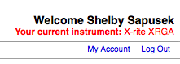

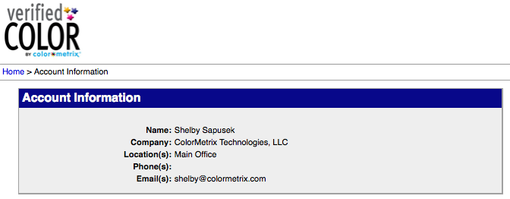

3. Return to the previous screen by clicking on the highlighted “Home” in the breadcrumb trail (navigation) under the VerifiedColor logo. When you use the system, if you are able to go back in the process, the screen name will be highlighted in blue in this spot.

Create and associate print companies (locations) and ink suppliers

- From the home screen, click on User Maintenance in the Administration box on bottom right.

- From the Edit Company drop down list, create a Print Company (Generic Printer) first. A Company Information box will pop up to the right. Fill out the print company’s location information in this box and click submit at the bottom of the page.

- Using the same process, now create a Generic Ink Supplier which can be chosen from the Edit Company drop down list. (Ink Suppliers may or may not need a location. This is up to the user.)

- Create an ink supplier contact by going to the Edit Contact, choosing Generic Ink Supplier and New from the Contact drop down menu. Enter this contact’s information.
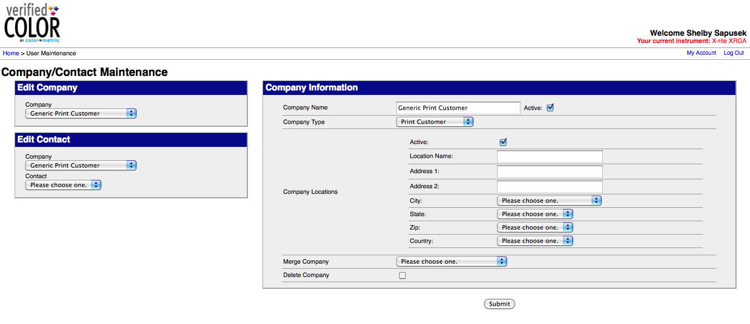

- Associate ink supplier contacts and printer locations by choosing the created contact from the drop down list under Edit Contact. Under the drop down list for Location, choose New Location. An ink supplier would have choices of entered print company locations. Choose the appropriate location and click the submit button at the bottom of the page.

- Repeat this process for known printing locations and ink suppliers or add them in the future as the need arises.

Create print customer

- Now that you have a few printing locations and ink suppliers created and associated in the system, you can create your customer database. Again choose User Maintenance in the Administration box on the bottom right of the Home page.
- Choose Generic Print Customer from the Company drop down menu in the Edit Contact box and then Other in the Contact drop down menu. A box will pop up where you can enter the customer name.
- Fill out the Contact Information and associate with correct company address in drop down.

File import/export

- You can import (and export) color measurements from other software such as our ProofPass or other third party software solutions such as SpotOn or DataColor. If you’re working with a QTX file, select that import/export option in the Administration box. If you’re working with a CGATS file, select the generic “File Import/Export” option.

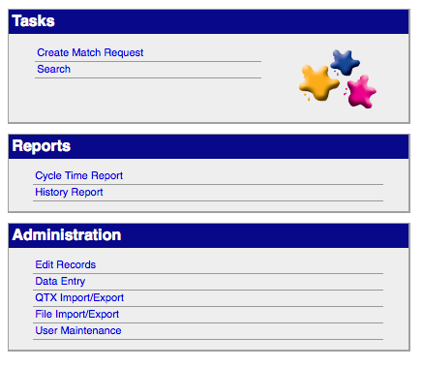
- On the next screen, you can import (or export) the appropriate file that you saved to your computer from the third party software. Be sure to check the default information for variables such as Delta E, instrument, board type, etc. before you click “Import.”

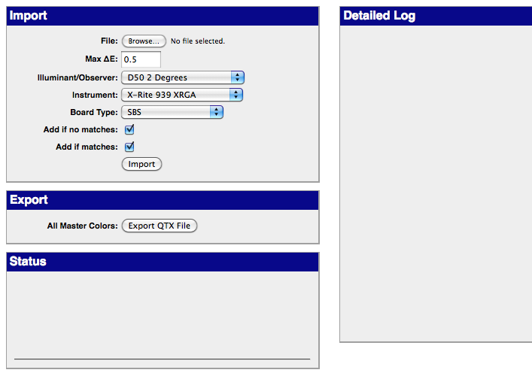
- Wait a few seconds for the import to complete. The status will be shown in the Status box and once completed you will see the results in the Detail Log at the right.
- To view your import, click on the Home button in the navigation breadcrumb trail. Then click “Search” under the task list on the right.
- On the next page, you can find your import by clicking on the drop down menu in the Master Color Search box. Choose the last one in the list (which is the most recent). Click Submit. The next page will show you all the details about that color.

NOTE: If you entered the wrong information on import for the color, you can change it using the Edit Records option. See Page XX.

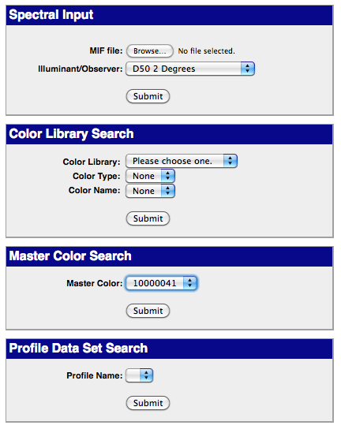

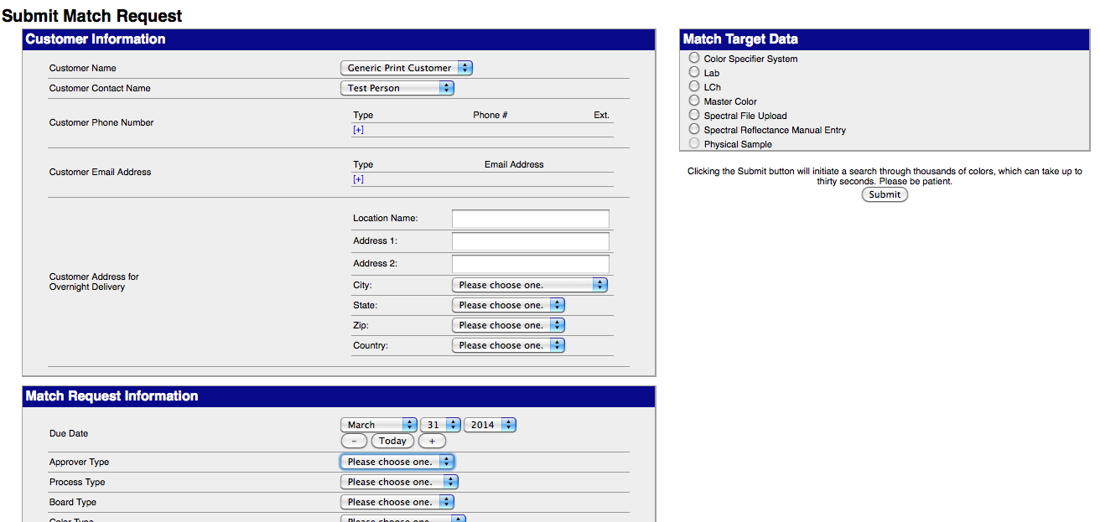

Create a match request

- Navigate to the Home page from the bread crumb trail under the VerifiedColor logo. In the Tasks box on the right, click on Create Match Request.
- Choose the correct customer name for whom the request is being prepared. If you have associated that customer with a location (see Pages 4 and 5), the Customer Information box will auto fill.
- Fill in the correct information in the Match Request Information box below and then choose the correct Match Target Data option in the box in the right. Then click Submit.
- When you view a swatch, a screen will be displayed like the one at the top of the next page. On the lefthand side, you will see the Customer and Match Request Information that was entered.
- The middle column shows the potential matches for the correct (top box) and best matches on different boards (bottom box). These are sorted by the least Delta E difference.
- The righthand column shows the target’s spectral graph and by scrolling you can drill down deeper by L*a*b*C*h* and download the target mif.

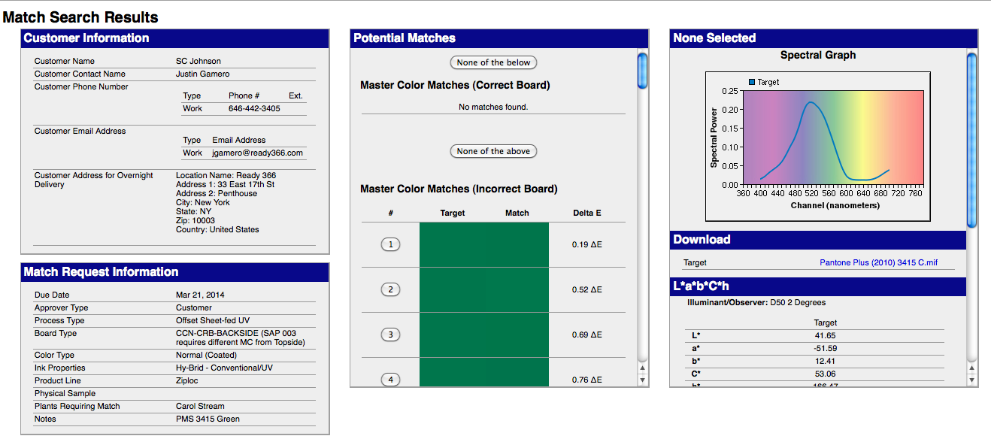

- If you see a potential good match in the center column that you’d like to review, click on the number before the entry. The righthand column will then show the comparison between the target and the potential match. If you want to suggest this as a good match, use the scroll bar on the righthand column to get to the bottom and click Submit.

Proposal Request Page

The last step for the person creating the match.

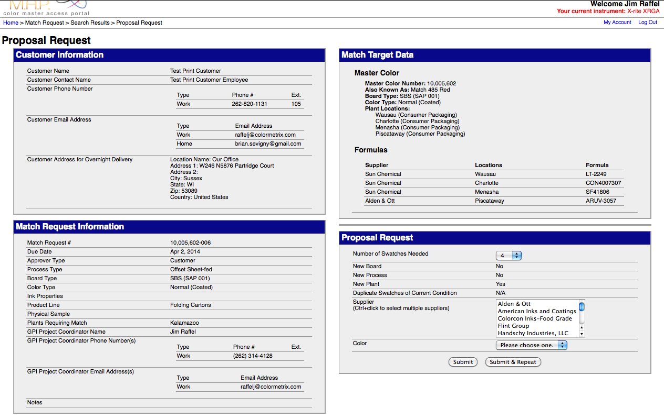

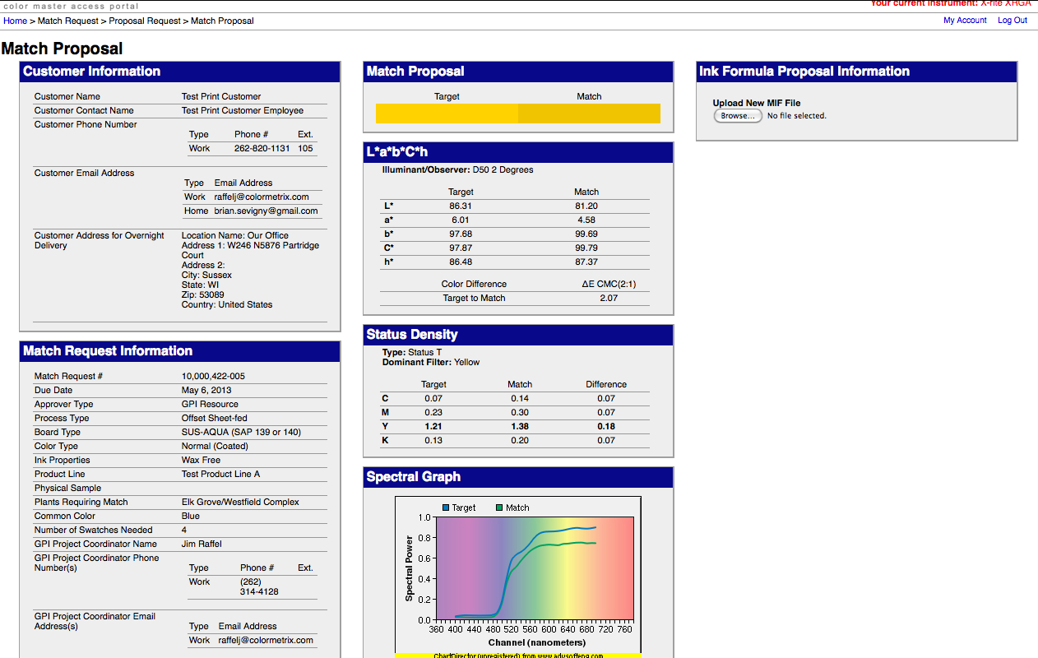

Match Proposal Page

The Page the Ink supplier completes and where they upload the measurement of their match [sample screen shot sent]

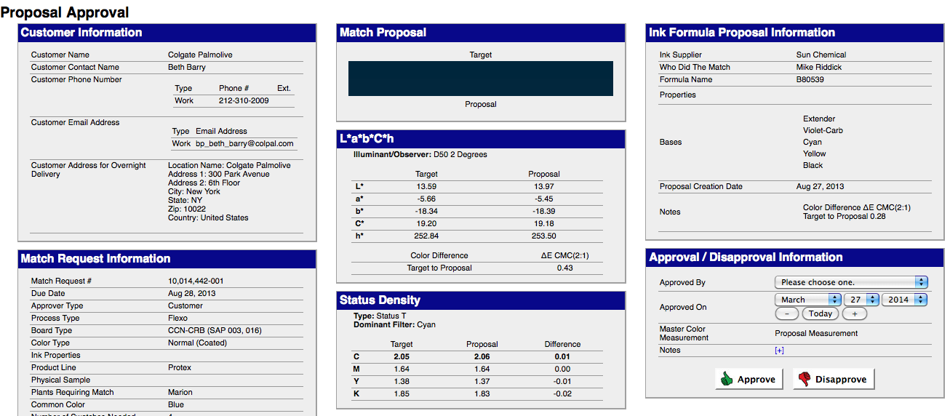

Proposal Approval Page

Once you click Submit in No. 7 above, you will be taken to the Proposal Approval Page. Here, you will see a complete breakdown between the target and the proposed match color. You can also approve or disapprove the match in the lower righthand box.

Proposal Letters

When a match is pending approval, a proposal letter is generated. The letter can be sent via email or printed. Search for Pending Approvals in the Recent Activity box on the Home Screen (See Page 12). You can view a proposal letter by choosing the “Letter” button.

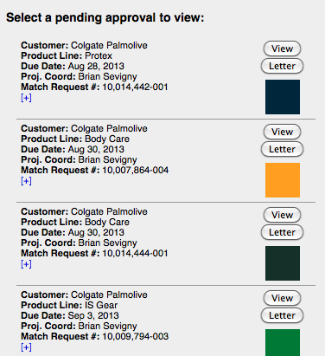

Stages of a Match Request

- Incomplete Requests: A request that has not been officially requested because all the information has not been entered.
- Being Matched: A request that is in the hands of the ink supplier.
- Pending Approvals: A request completed by the ink supplier awaiting approval or rejection.
- Pending Rejections: A rejected match awaiting further action by the match request creator or the ink supplier
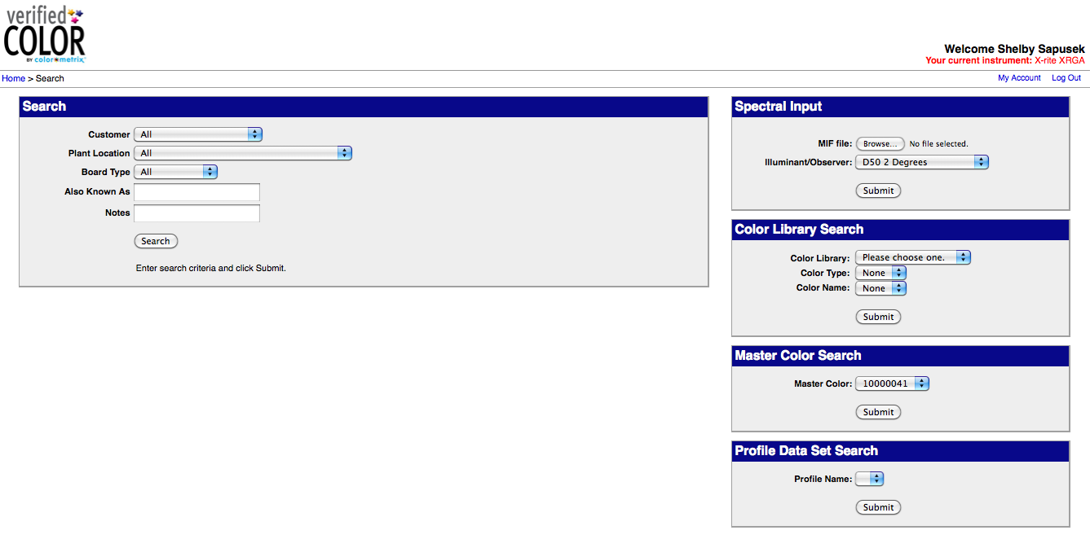

Searching the database

- Navigate to the Home page from the bread crumb trail under the VerifiedColor logo. In the Tasks box on the right, click on Search.
- From this page, you can search the database in many ways. In the box on the left, you can search by customer, plant location or board type. This is also where you can search for customized names (Also Known As) and any information you have added to a color’s notes section.

NOTE: If Also Known As and Notes were not entered previously, you can add both in the Edit Records section. See Page XX.

3. Other search capabilities are available in the boxes on the right where you can search by Spectral Input, Color Library, Master Color Number and Profile Name.

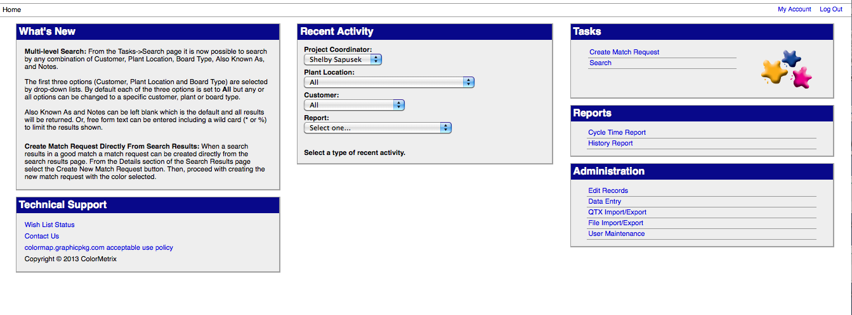
Recent Activity

- The center box on the Home Screen is a quick view module to see what is in progress in the system. The following are the ways in which you can search from the Recent Activity box:

- By Project Coordinator: The person overseeing the match request
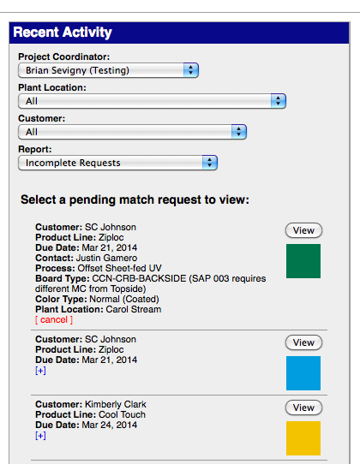
- By Plant Location

- By (Print) Customer Name

- By Report (stage of process, which includes incomplete requests, colors (inks) being matched, pending approvals and pending rejections.) This option will open up swatches and information for in progress requests. For each that pops up in the search, you can expand the information associated to it by clicking on the blue + at the bottom. You can also click the View button above the color swatch.

2. When you view a swatch, a screen will be displayed like the one above. On the lefthand side, you will see the Customer and Match Request Information that was entered when it was first created (See Page 8).

3. The middle column shows the potential matches for the correct (top box) and best matches on different boards (bottom box). These are sorted by the least Delta E difference.

4. The righthand column shows the target’s spectral graph and by scrolling you can drill down deeper by L*a*b*C*h* and download the target mif.

5. If you see a potential good match in the center column that you’d like to review, click on the number before the entry. The righthand column will then show the comparison between the target and the potential match. If you want to suggest this as a good match, use the scroll bar on the righthand column to get to the bottom and click Submit.

NOTE: This is the same process as Creating a Match Request on Page 8.

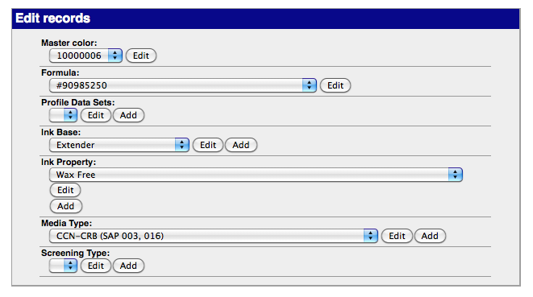
Edit Records

- From the Home page, click on Edit Records in the Administration box in the bottom righthand corner.
- From this screen, you can edit almost anything associated with a Master Color including the number, formula, ink properties and the notes and also known as references for easier search capabilities.’

NOTE: The more complete you are with your naming conventions and entering information for a color, the better and more searchable your overall database will be.

Cycle Time and History Reports

Again from the Home Page, you can choose either Cycle Time Report or History Report from the Reports box (middle box on righthand side.)

Cycle Time Reports allow you to view the activity in the overall database within a certain time period exported as a CSV file that can then be reviewed in a spreadsheet report.

History Reports show the activity of a particular Master Color number, match request or formula and allows for deleting and restoring the associated records if you security level is high enough.

Troubleshooting, Support and Feature Requests
While this guide is intended to aid you in your day-to-day use of VerifiedColor, there are other features available within the system.
To report any problems with your VerifiedColor account or to discuss new development features or requests, please email ColorMetrix Project Manager Shelby Sapusek at Shelby@colormetrix.com or call her at
414-510-6590.

